**PYTHON CHALLENGE HOME WORK ASSIGNMENTS - READ ME**

Overview

I wrote Python Scripts for all the 4 assignments a) PyBank b) PyPoll

c) PyBoss d) PyParagraph.

All scripts were developed and tested in the Python IDE – PyCharm. The scripts and datafiles were separated into separate folders. The data files were stored in a “DataFiles” folder under the folder where the source code resides. So all reference to the data files is made using the folder “DataFiles” as shown below in the screen shot. *The python scripts are loaded in the repo python-challenge*.

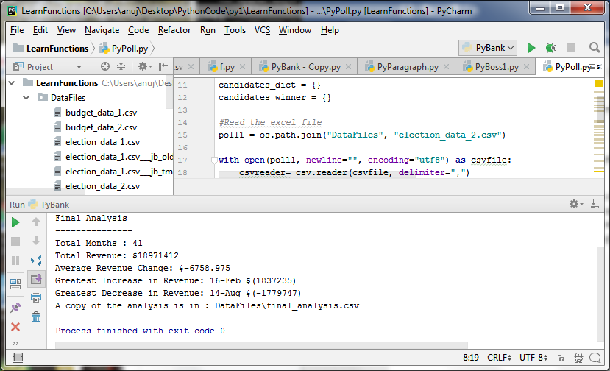

**PYBANK**

1. PyBank output using input file: budget_data_1.csv

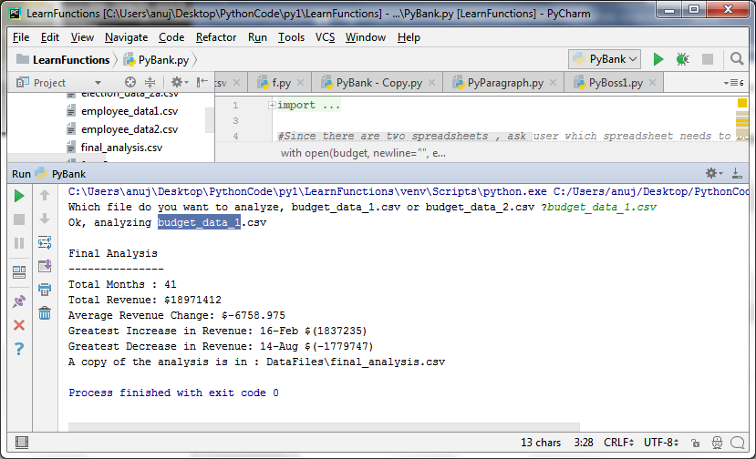

PyBank output using input data file: budget_data_2.csv

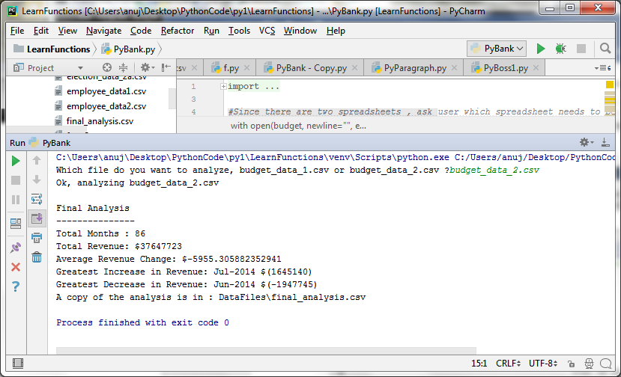

**PYBOSS**

Please see attached output file pyboss_output1.csv

**PYPARAGRAPH**

Used the following text to get the word count, sentence count, sentence length and letter count.

***My name is Anuj. I am young? But my wife does not think so!***

A line is considered a sentence when it ends with a “.”, “?” or “!”. Used regular expressions to derive results. Please see output below:

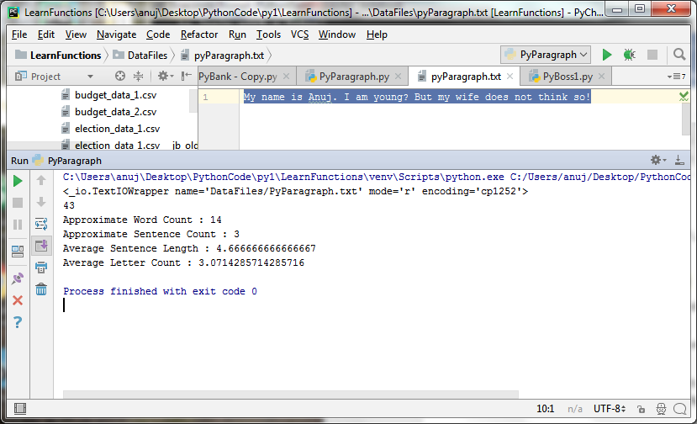

**PYPOLL**

Output for source data file: **election_data_1.csv**

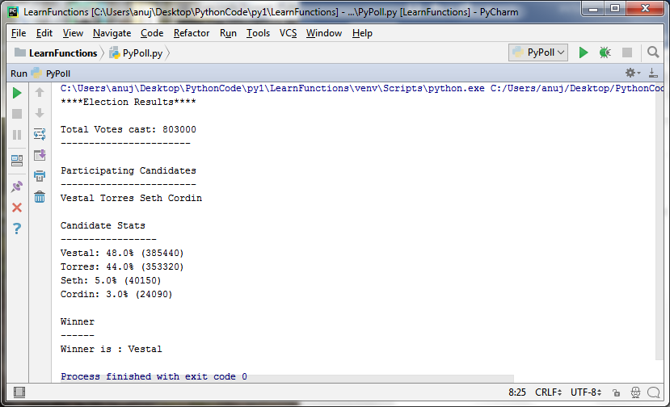

Output for source data file: **election_data_2.csv**

